Sales Rep Learning Coach — Demo Script
Demo Action | Screenshot | VO
Joule Studio open. Create Agent dialog. Name field shows "Sales Rep Learning Coach" being typed. Intent Statement field empty. | 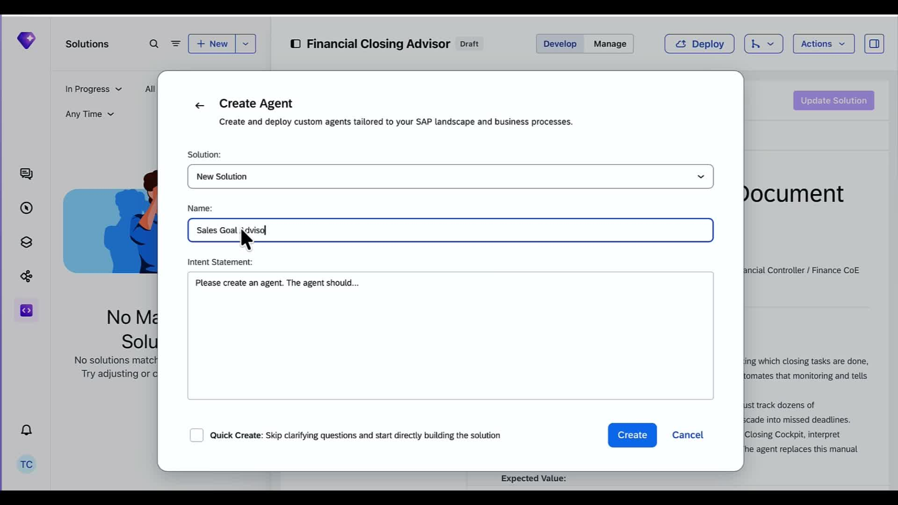 | Hey there, I'm Michael Ye from the SAP product marketing team.  Today I’m going to show you how to build a sales coaching AI agent on Joule Studio.  At quarter end our sales team needs to submit their goals. To track them  Sales reps have a ton of performance data from pipeline numbers, win rates, and activity metrics. But it might be too much data. I’m not sure what are the tangible learning and development goals to focus on.  Let's see if I can build an agent to help us out.
Sales Rep Learning Coach project open. Requirements panel shows empty state. Chat panel shows intent submitted — Joule reads it, activates skills, calls 2 tools, reads files. | 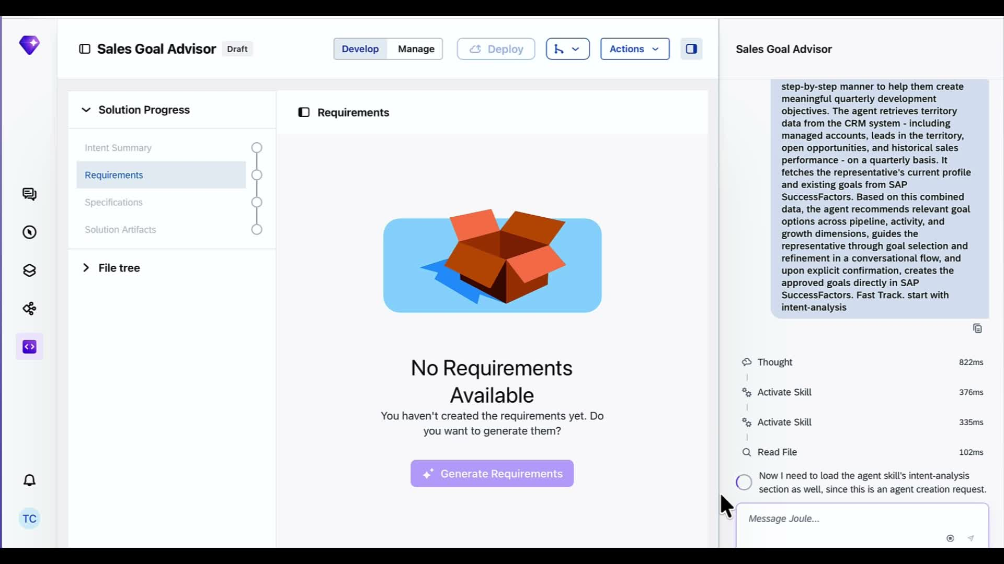 | Joule Studio is our intent based development envinoment  Right away, is going to be scanning our SAP landscape, and mapping the business process across SAP Sales Cloud and SuccessFactors.  Our agent is going to be only as good as it’s context,
Joule surfaces clarifying question: needs a measurable business goal and success metric. Shows suggested examples — reduce goal-setting time from X hours to Y minutes. | 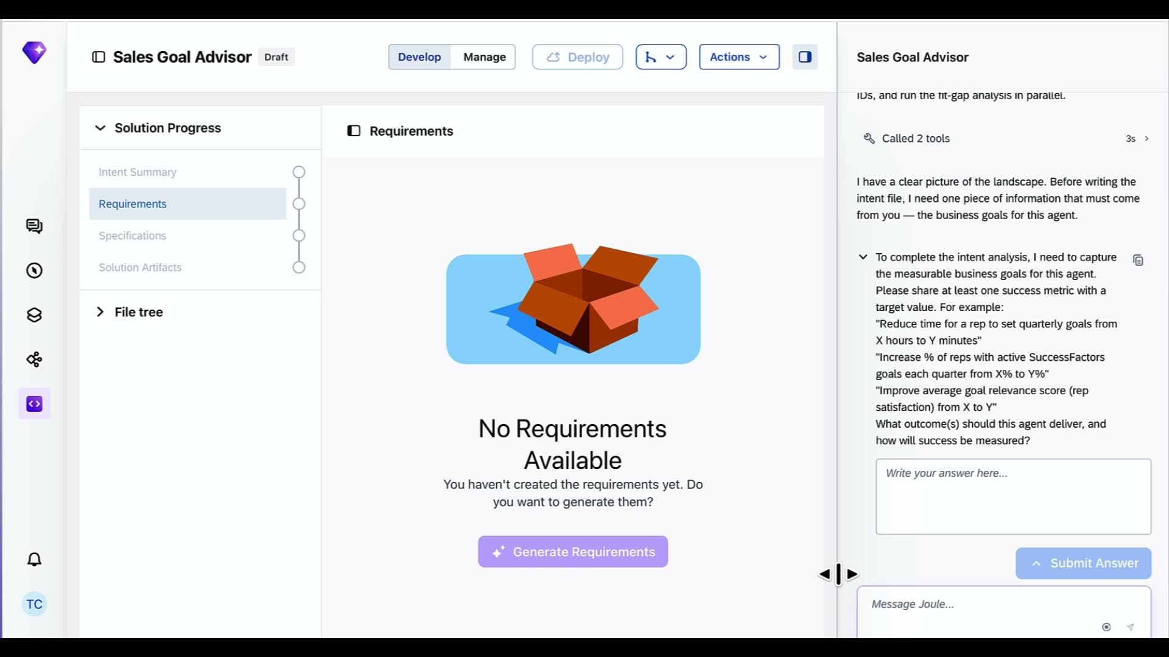 | Now Joule Studio is asking one clarifying question. It needs a measurable business goal to refine our intent  My big problem I care about is reducing how long it takes a rep to set quarterly goals.
Chat shows user answer typed: "Reduce a goal setting time from 2 hours to 15 minutes." Joule proposes a metrics table showing Baseline 2 hours, Target 15 minutes, per quarter. | 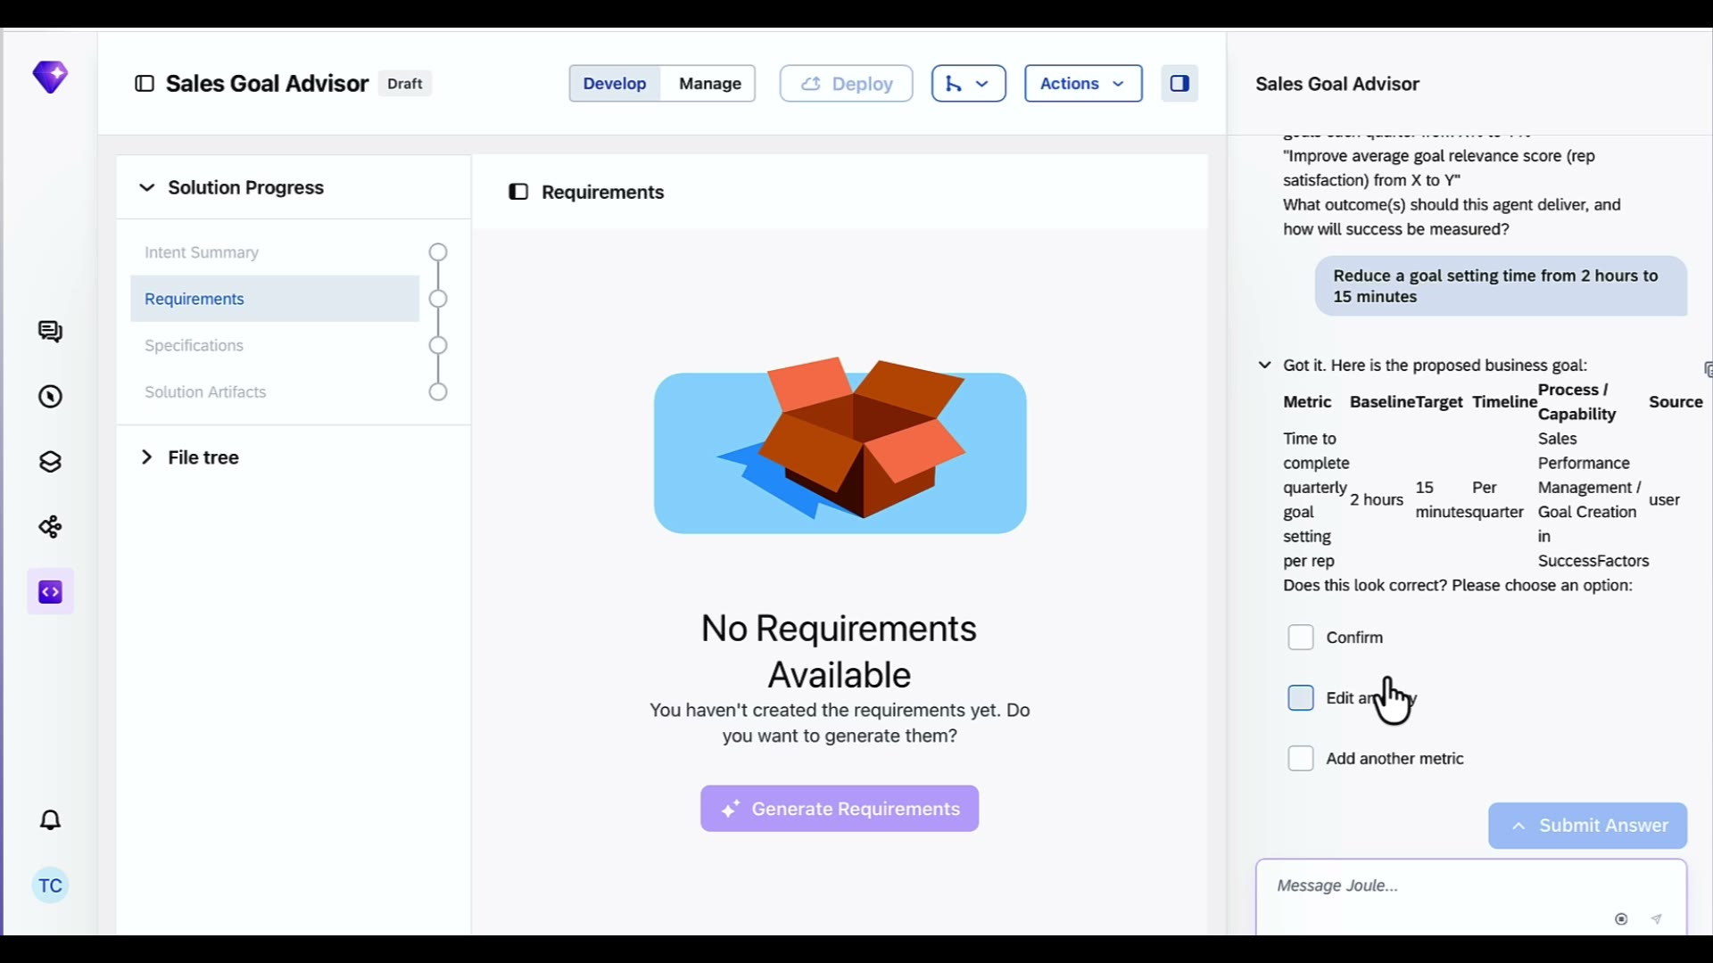 | Say I want to reduce goal-setting time from 2 hours to 15 minutes per quarter.  Joule Studio reflects that back as a structured business goal. If it looks right, we confirm and move on.
Confirm checkbox selected. Chat shows quick confirmation summary — challenge, goals, solution, fit gap. "Proceeding to write intent.md now." | 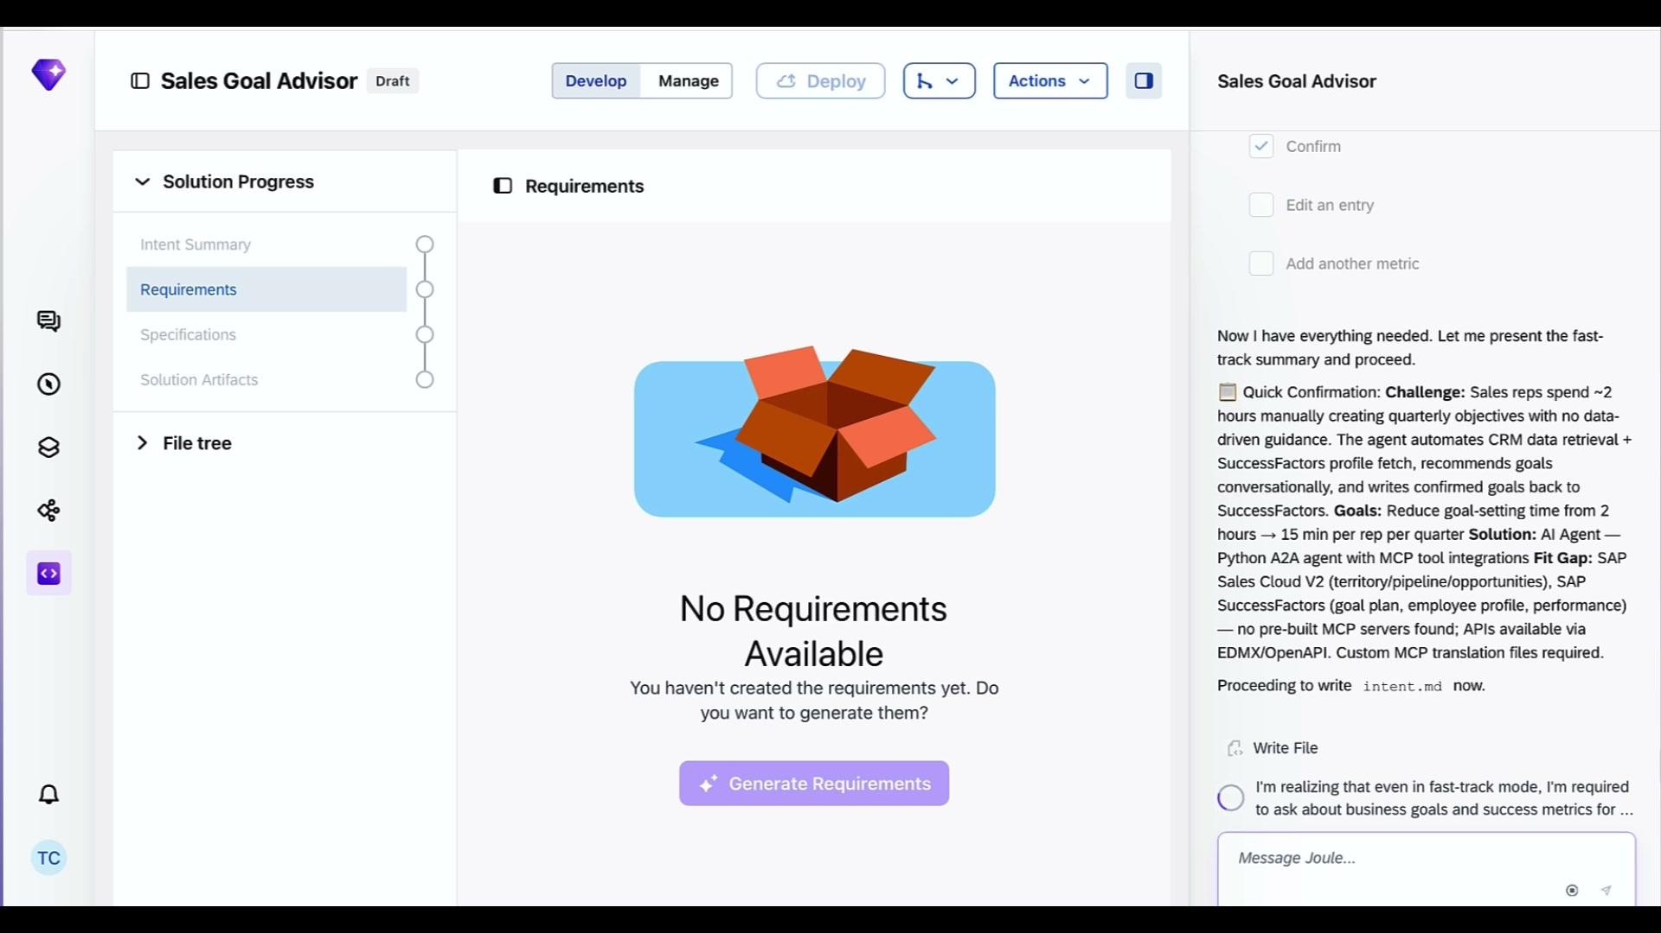 | Now it is writing the intent file. This helps us check in with Joule Studio to make sure it fully understands our problem.  While that's happening, let me explain what problem we're solving.  Although important, It’s a hassle to write goals backed by key metrics. Sales reps today have to open the CRM, dig through accounts and pipeline numbers, then switch over to SuccessFactors, pull up last quarter's goals write your progress, and try to write new ones that actually connect to your activity data.
Generating Requirements spinner shown. Chat shows PRD outline — 5 milestones, personas: Sales Representative and Sales Manager, architecture: Python A2A agent with MCP tools. | 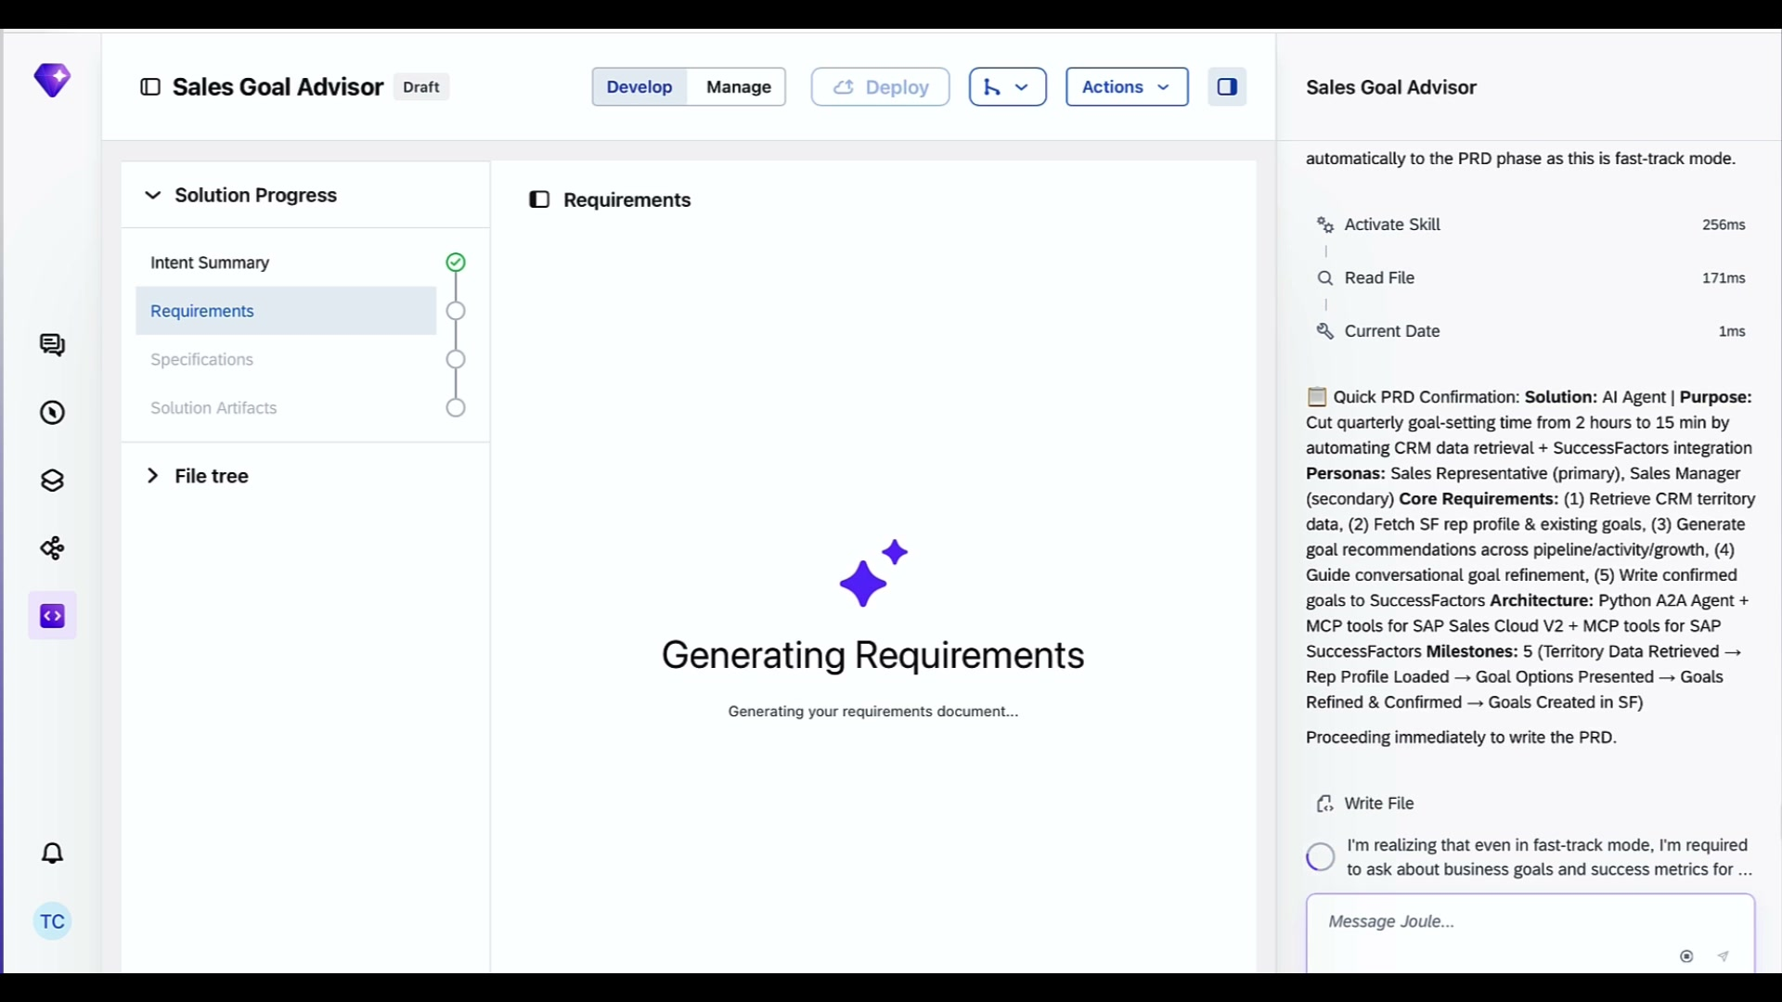 | Looks like Joule Studio generates the Product requirement document for me. Gives me the full scope of this solution.  Here is what this agent actually does: it pulls info of the rep's territory data from SAP Sales Cloud and also loads their existing profile and goals from SuccessFactors.  The agent then recommends new goals based on what the data actually shows. The rep can refine the goals through a quick conversation, and the agent writes them straight back into SuccessFactors
File Explorer shows product-requirements-document.md content. Spec section shows PRD complete. Right panel: Joule running API discovery for SAP Sales Cloud and SuccessFactors simultaneously. | 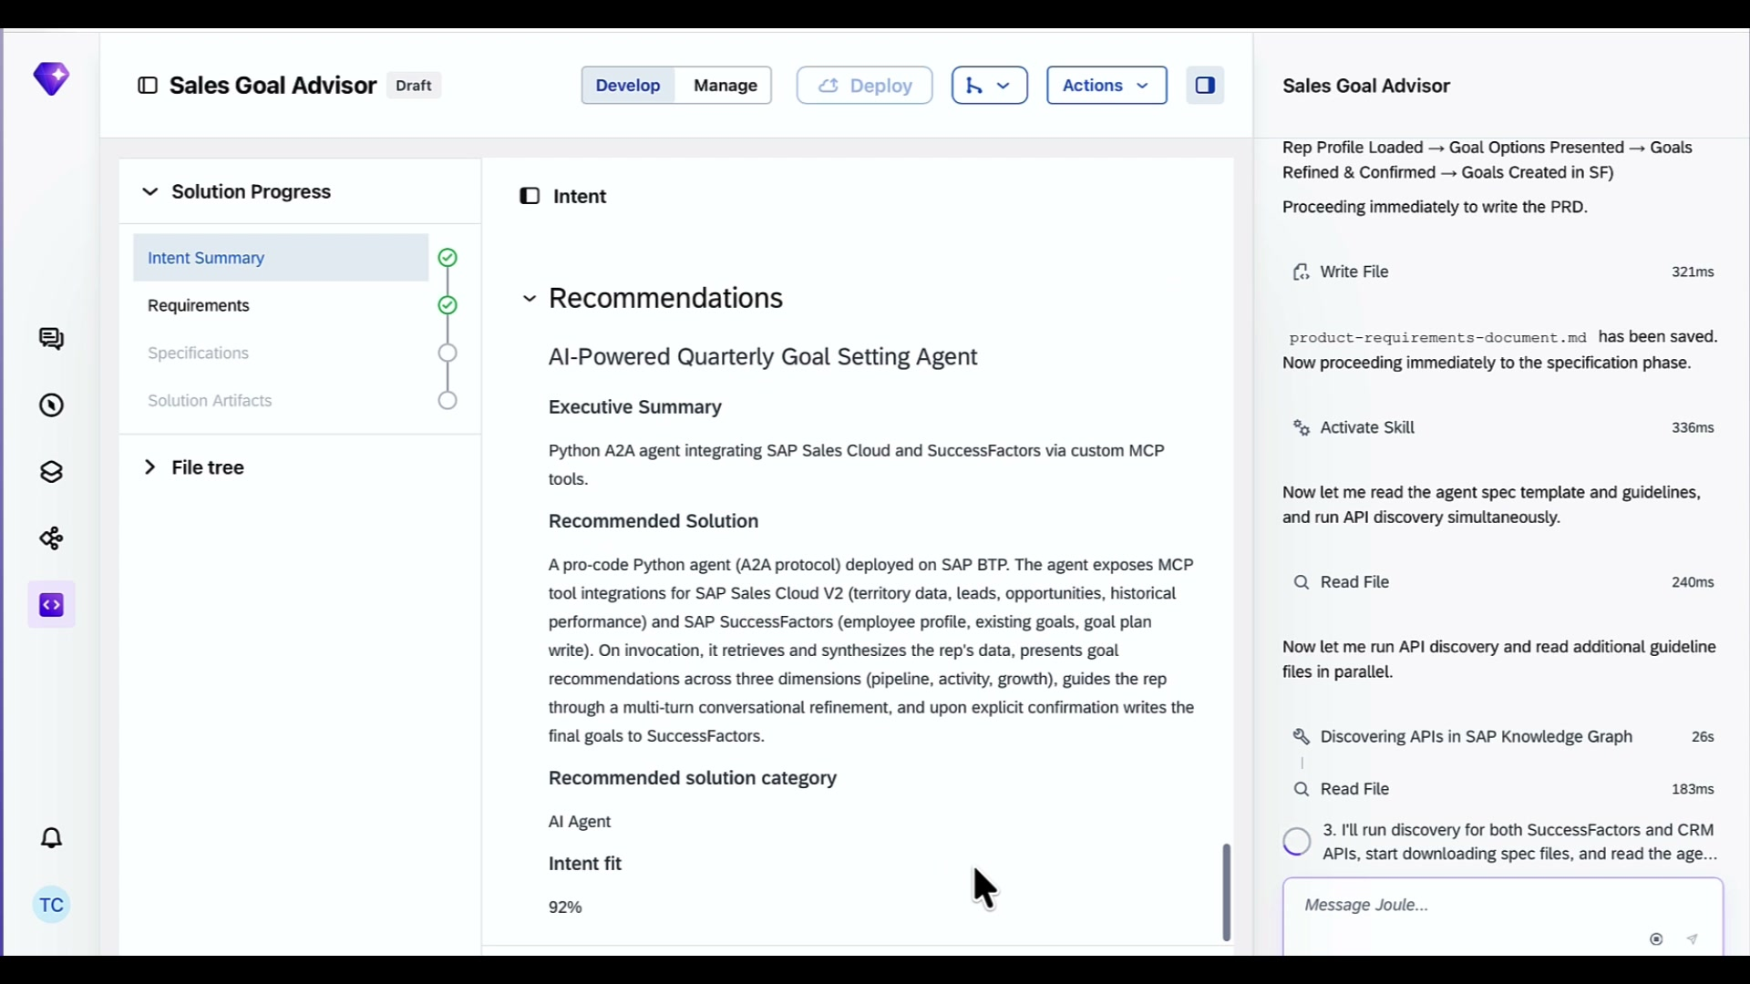 | Our other document is specification, which tells Joule Studio how we build it.  It contains the skills for runtime and guardrails. Rules like — the agent can never write goals to SuccessFactors unless the rep explicitly confirms
Spec and Requirements both checked green. File tree shows specification/ folder, intent.md, product-requirements-document.md. Chat says: "Generate Solution" button appears. | 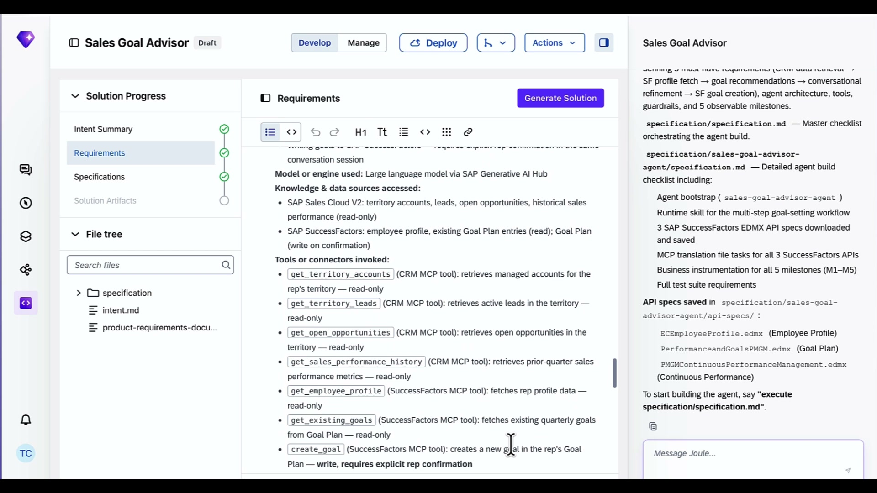 | Joule Studio has everything it needs to start building. I'll type in execute specification.
Solution Artifacts complete and checked green. sales-goal-advisor-agent selected in sidebar. Main panel shows agent overview — System Prompt undefined, LLM Configuration: sap/anthropic-claude-4.5-sonnet, Circuit Breaker settings visible. | 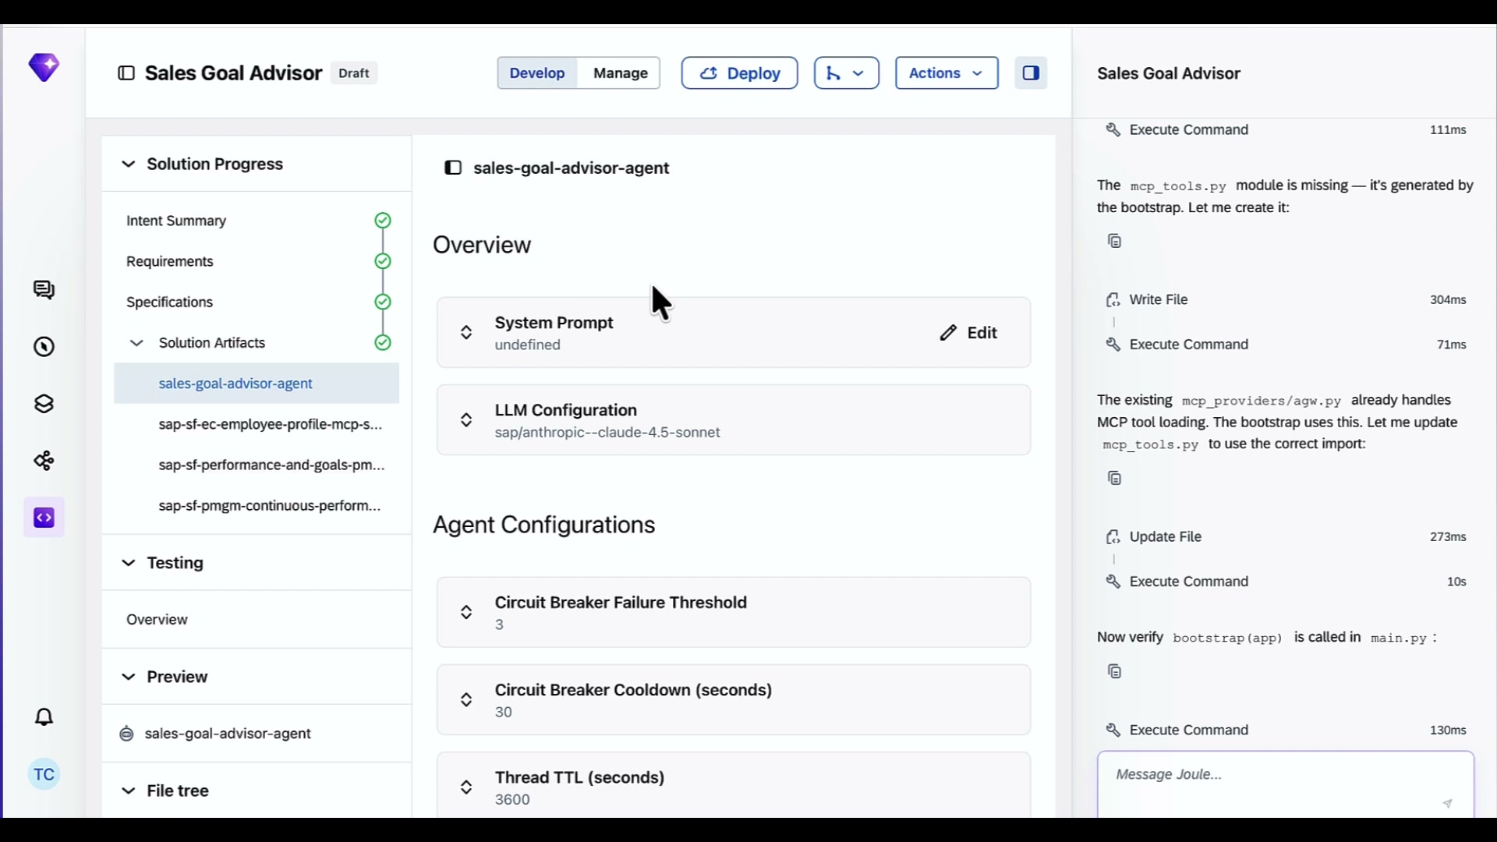 | Over in the sidebar, you can see the generated assets:  you can see the Sales Rep Learning Coach agent and three MCP servers.  I can also choose which LLM model powers this agent at runtime. It's defaulted to Claude 4.5 Sonnet. For a goal setting conversation like this, Sonnet is a great fit. Fast, and cost-effective.
LLM model picker dropdown open. Shows providers — Alibaba, Amazon, Anthropic, Google, OpenAI, Perplexity, SAP. OpenAI models listed on right. Current selection shows claude-4.5-sonnet. | 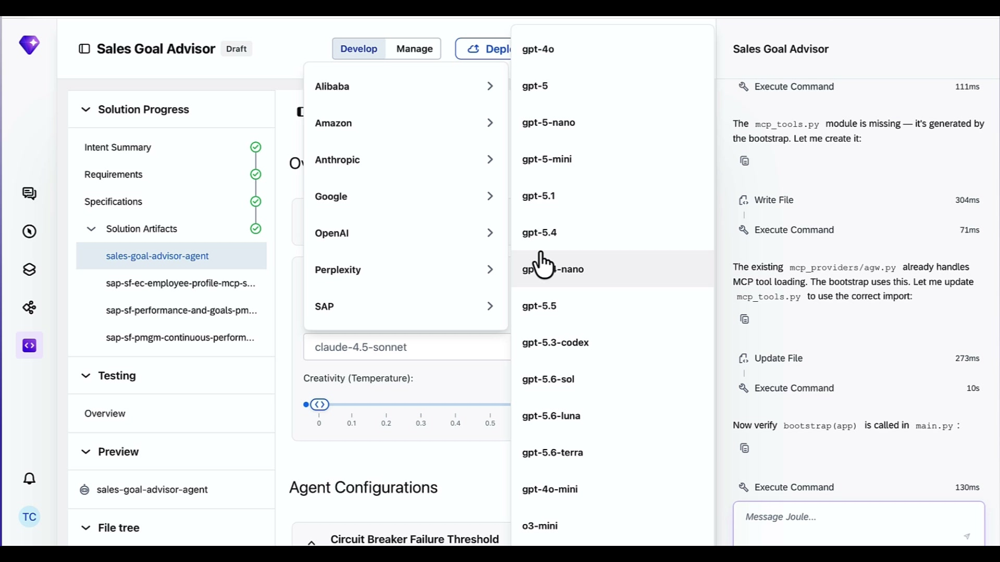 | You can see the full model picker here. Anthropic, Google, OpenAI, SAP's own models. The agent is not locked to one provider.  Depending on the use case, you can swap the model without touching the agent code.
sales-goal-advisor-agent Preview panel shown. Main panel shows "Try Your Agent" with chat input. Traces and Logs panel visible. | 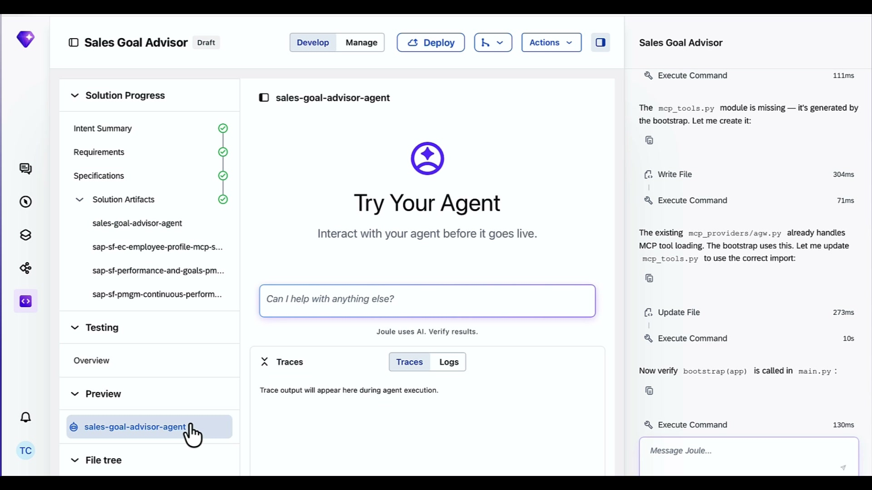 | This is the Try Your Agent preview. Before this goes anywhere near a production user, I can interact with the agent right here and watch what happens in the Traces panel.  Every tool call the agent makes, every API it hits, shows up in real time. That is your observability layer built in.
Testing Overview panel. Left sidebar shows Testing > Overview. Main panel shows "No test reports available" with Test Solution button. Chat panel preparing mcp-mock.json. | 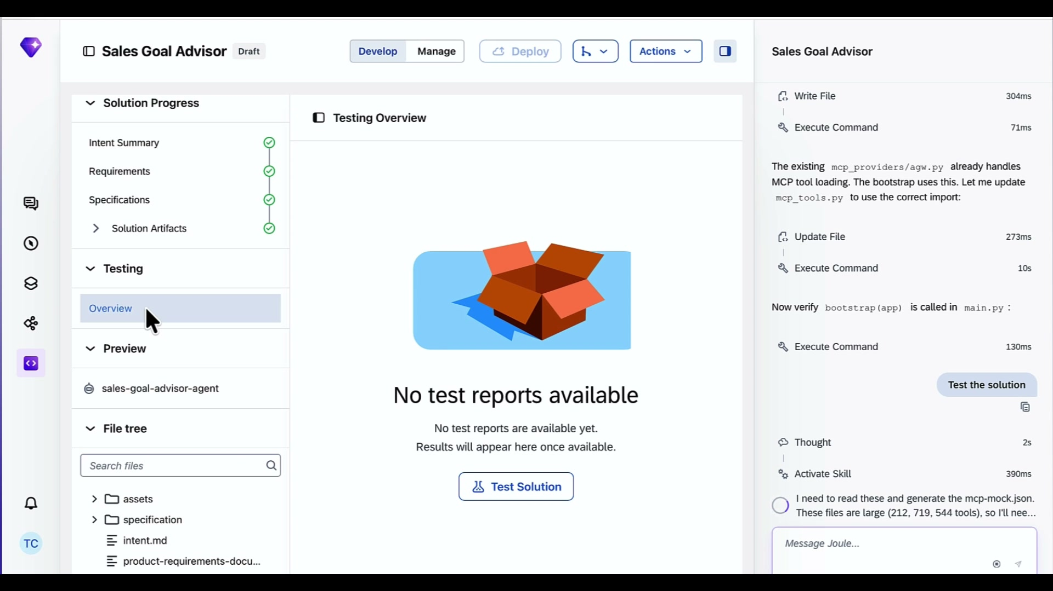 | Now testing on the right. Joule Studio is generating mock configurations for all three MCP servers so it can test the agent logic separate from the infrastructure.
Testing Overview screen stays the same across multiple frames. Chat panel shows 87/87 tests passing, 71% coverage. Joule fixing 2 tests to be more flexible for environment defaults. | 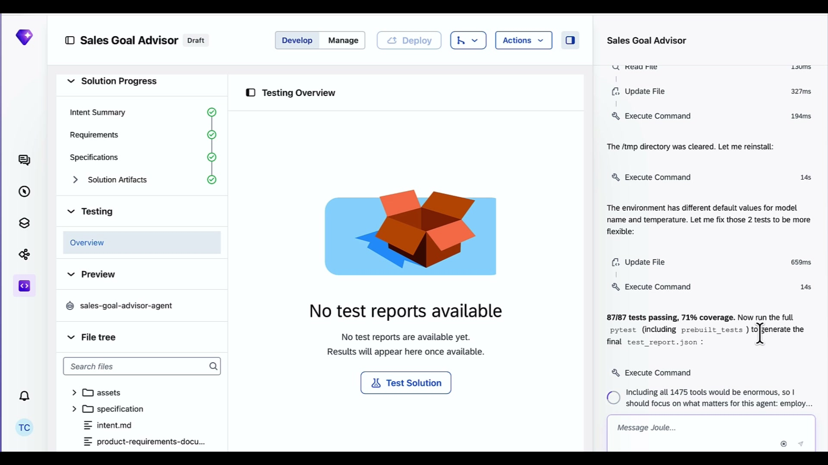 | 87 tests. 87 passed. Zero failures.  Those tests validated the optimization engine across all five milestones — territory data retrieval, rep profile load, goal recommendation logic, conversational refinement flow, and the SuccessFactors write operation.  That is the confidence you need before this goes anywhere near a production user.
sales-goal-advisor-agent main panel. "Deploying Agent" spinner shown. Chat shows: deployment quota checked, all 3 translation files valid, Deploy Solution running. | 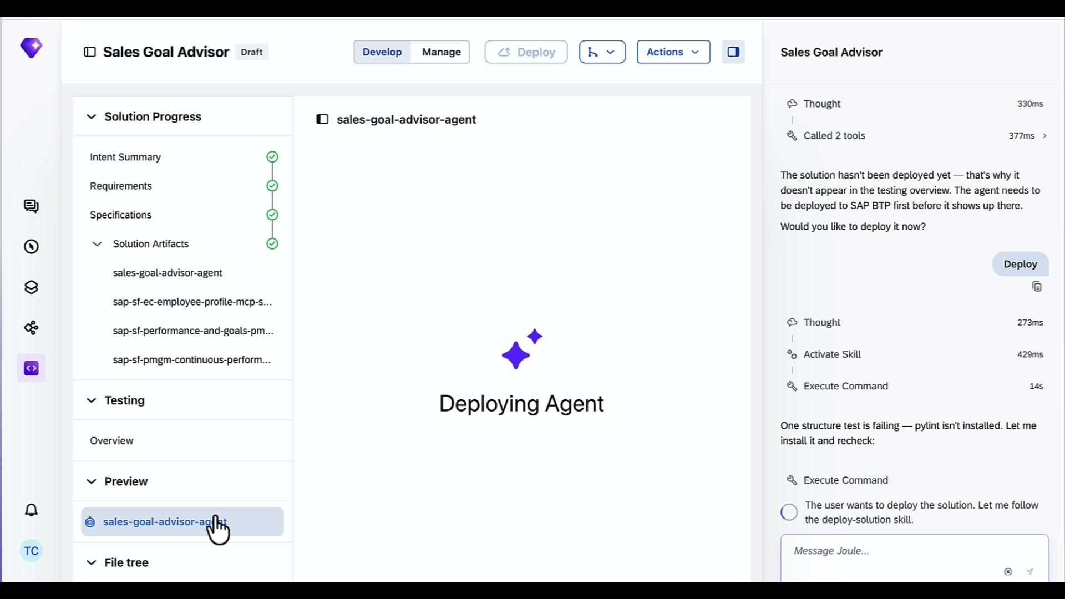 | Joule Studio is now deploying. is pushing all four assets to the managed runtime on.  No infrastructure to configure. No Kubernetes to manage. Joule Studio handles all of that.
Deploying Agent spinner continues. Chat panel shows Called 6 tools, then Called 8 tools as deploy progresses. All 3 translation files valid confirmation visible. | 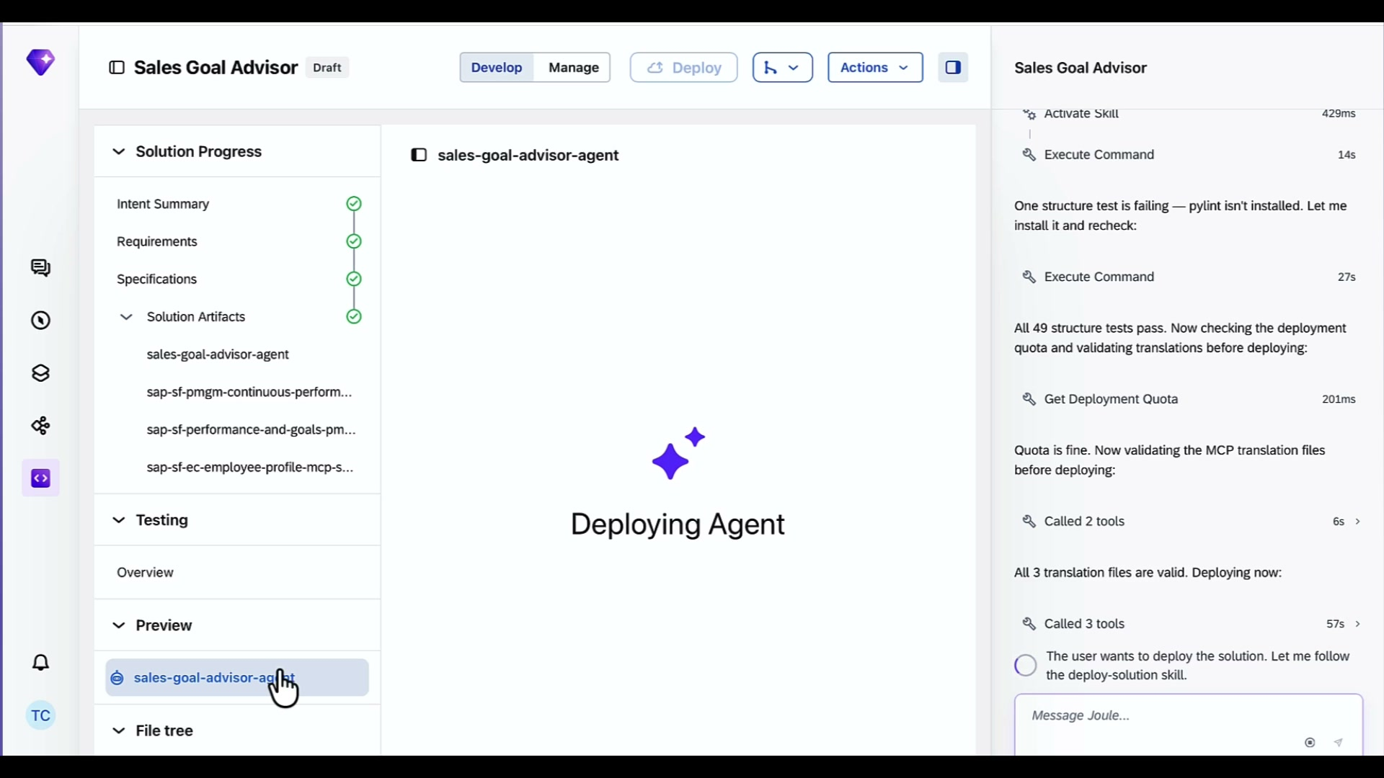 | While that deploys, here is a basic agent but a full production version of this agent could do beyond what we built today.  I could pinpoint skills gaps and it could integrate with learning resources to give sales rep actionable training resources It could track skill learning progress across the quarter and flag reps who are behind.  This usually take 4-5 minutes to get an agent fully deployed on Joule runtime. I’m going to take a break and be back to close off this video after the deployment
Deployment successful. Chat shows: "The Sales Rep Learning Coach Agent is now live." MCP servers still wiring up. Authorization Required shown for agent, but MCP servers show Running status. | 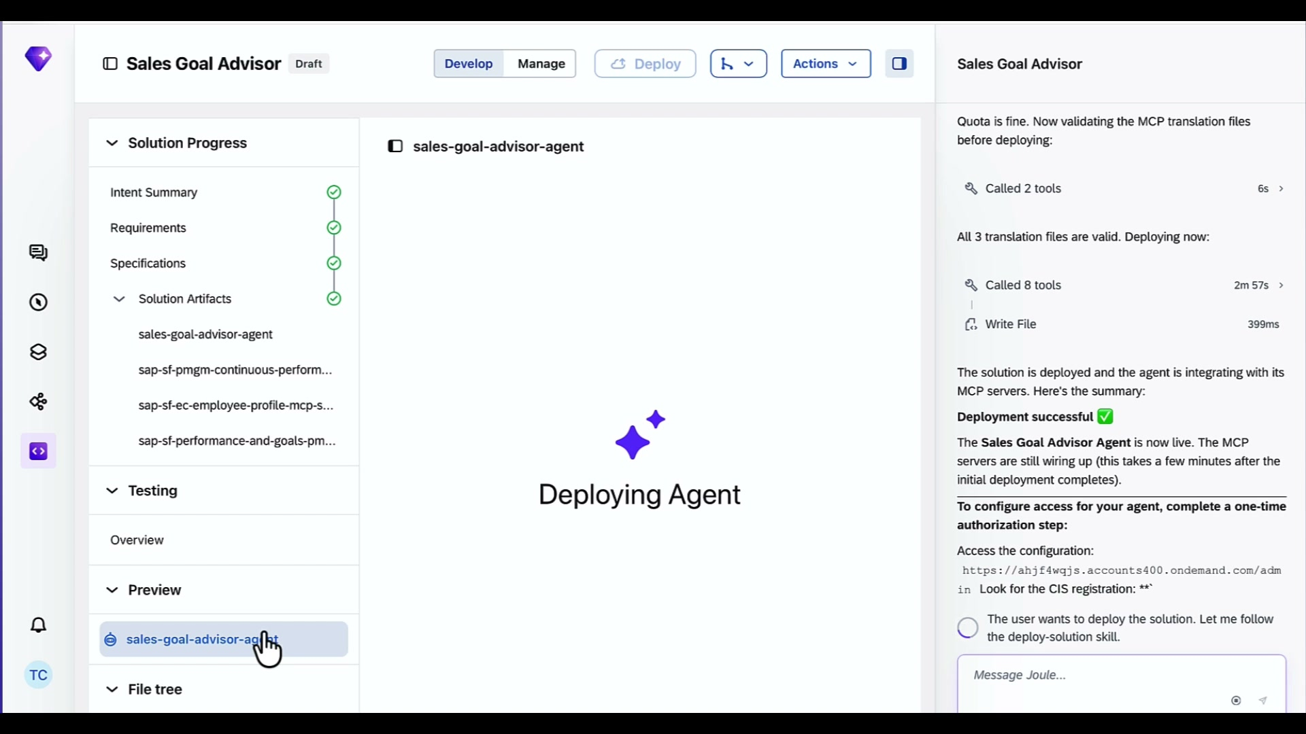 | Deployment successful.  The agent is live. The three MCP servers are running.
sales-goal-advisor-agent Preview panel shown. "Try Your Agent" screen with chat input. Traces and Logs panels visible. Deployment successful shown on right. | 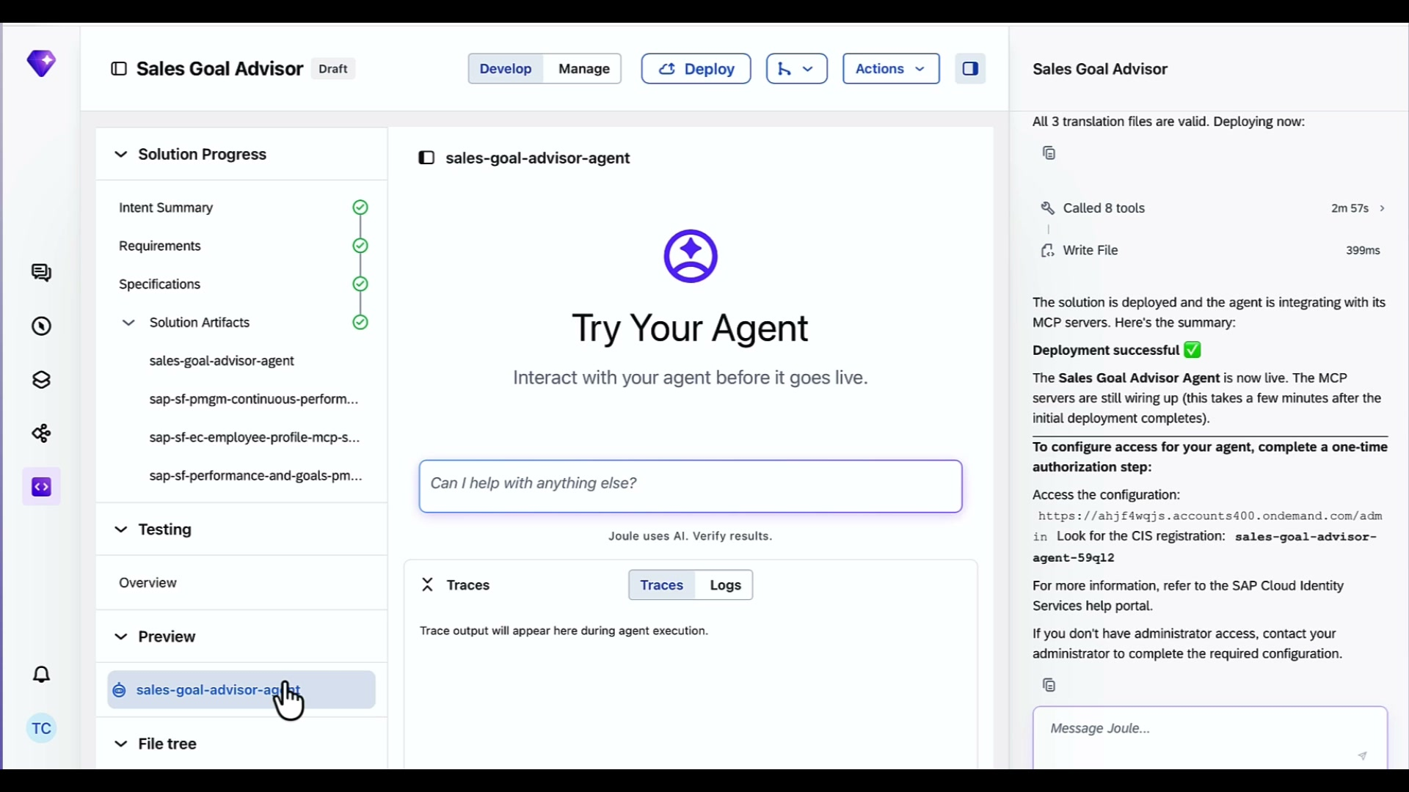 | Here, I can test our Sales Rep Learning Coach agent live in preview.  A sales rep can start a goal conversation with Joule, and the agent will pull their territory data, load their SuccessFactors profile, and guide them through setting meaningful quarterly goals.
Manage tab active. Overview panel shows all 4 assets — sales-goal-advisor-agent (Integrating / Authorization Required), sap-sf-pmgm MCP Server (Running), sap-sf-ec MCP Server (Running), sap-sf-performance MCP Server (Running). Completed Runs and Failures both 0. | 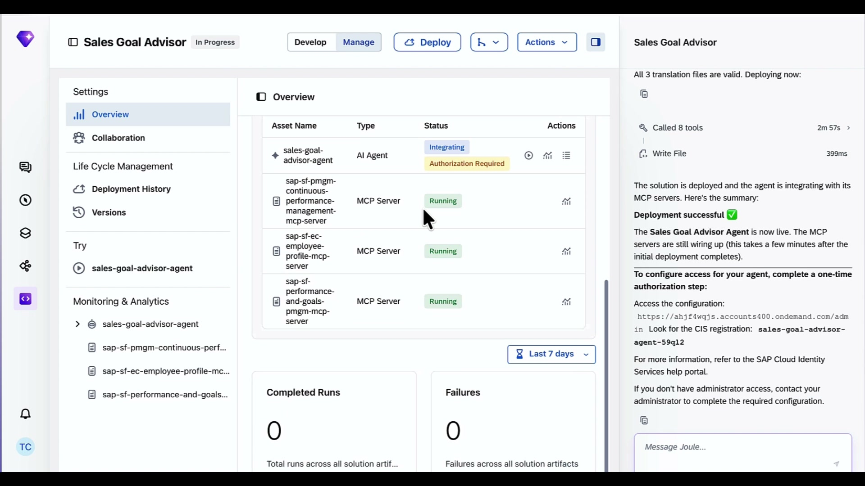 | That is a quick tour of Joule Studio and how to build a useful line of business agent for your sales teams.  Thanks for watching.

